
VPS ARTICLE

The Cost of Caution in 2-Stroke Cylinder Lubrication

Joe Star – VPS Strategic Account Manager

27th October 2025

The Role of Cylinder Oil
More than 90% of global freight is transported by over 33,000 merchant marine vessels powered by two-stroke crosshead engines as their main source of propulsion; the two-stroke diesel engine has been the backbone of global trade and globalisation for well over half a century. Among one of the key factors supporting the reliability and uptime of these engines, keeping trade moving, is the effective performance of cylinder oil. Often referred to as the lifeblood of the engine, these oils provide critical protection to avoid abrasive, adhesive or corrosive wear from occurring within the engine; whilst maintaining a clean environment free of deposits.
Key Responsibilities of a Cylinder Oil:
- Provide a full and stable oil film throughout the cylinder liner surface to minimise adhesive wear and metal-to-metal contact.
- Provide corrosion resistance within the cylinder, through neutralising the sulphuric acid formation which occurs within the combustion chamber.
- Minimise deposit formation on piston rings and liner surfaces, by providing detergency to remove particulates and preventing the build-up of hard deposits in key component areas.

Prior to the introduction of Emission Control Areas (ECA’s) and more advanced engine designs coming to market, (designed to cater for increased pressures and temperatures, maximising thermal efficiency), the cylinder oil landscape was largely static, and performance priorities were clear. SAE 50 oil viscosity, provided the optimum film and hydrodynamic lubrication properties, whilst Base Number (BN) 70 provided sufficient neutralisation and detergency properties.
Over the last 20 years, the rapid development and introduction of differing cylinder oils has led to increased complexity onboard. The 2020 Sulphur Cap reset much of this complexity, with the industry and Original Equipment Manufacturers (OEM’s) standards coalescing on 40BN as the optimum for non-scrubbed vessels and a wide range of fuels, with some oil formulations including neutral detergency to boost clean performance.
More does not mean greater reliability
With vessel operations being far reaching and extensive, consistent reliability is paramount, from both a time and resource perspective and in ensuring an asset is maximising its earnings potential. A stable and proactive reliability strategy allows for additional initiatives to be progressed, in place of one which is reactive to reliability-based events. Due to this, there may be the viewpoint to increase the amount of cylinder oil used to further promote reliability and avoid any unforeseen lubrication issues that can be costly. As reported by the Swedish Club, the most frequent causes of main engine damage are lubrication related issues.
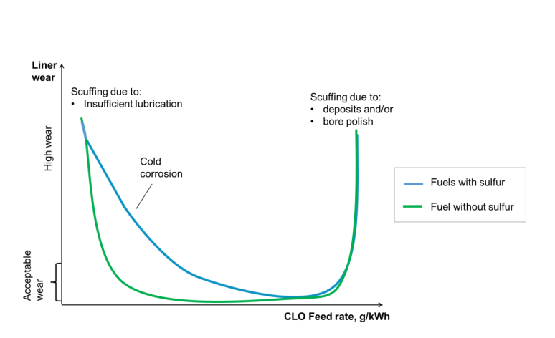
Figure 1 - 2023-03-02_CIMAC_Guideline_Scuffing
However, additional cylinder oil within the system, not only represents a hidden cost to enhance reliability, but can also lead to significant reliability related issues which occur and manifest over time. Additional lubricant additives that are designed to react with Sulphuric Acid within the engine, can form hard deposits on piston rings, and in extreme cases polish the cylinder liner surface. This leads to scuffing, or engine seizing, due to future lubricant injections being unable to maintain the film thickness and distribution required within the engine. The key indicator of potential over-lubrication in this instance, is the lack of depletion of Base Number when compared to the fresh Base Number of the cylinder oil in use. Note, OEM’s recommend a safe level to be in excess of 10-15mg/KOH for the majority of cylinder oil and fuel combinations in use, with both Everllence and WinGD recognising the dangers that over-lubrication can bring.
Feed-Rate reality post IMO 2020
Leveraging VPS’ extensive database of oil analysis results gathered from a range of vessels and operating conditions, the average feed rate onboard during 2025 is currently 1.05g/kWh. This is over 35% higher than Everllence (MAN ES), and WinGD’s recommended minimum feed rate for routine engine operation. The vast majority of samples continue to show close to fresh BN levels for those vessels using 40BN products onboard, with BN levels routinely ranging up to 75BN for higher BN products used in conjunction with HSFO bunkers.

Figure 2: VPS Tested Samples: Feed-rate distribution

For majority of the merchant fleet, the potential prize in optimising lubricating oil feed rates to account for the fuel’s lowering sulphur content, (due to the IMO2020 global sulphur cap of 0.50%), has never been more apparent; particularly in a volatile Group I base oil environment that leads to dynamic cylinder oil pricing.

Figure 3: BN (mg/KOH) Distribution
As previously mentioned, elevated and consistent results reporting low total Iron (Fe) content as an indication of mechanical and corrosive wear, coupled with BN results in excess of 20mg/KOH, provide a platform for vessels to iteratively reduce feed rates based upon ongoing onboard quick monitoring, and detailed lab analysis. Scenarios will continue to exist where feed rates should be temporarily elevated, such as the running-in of engine components, or cylinder liners. However, these should be on a temporary basis, following OEM guidelines and reverting once wear metals are within limits. A review of VPS’ database shows substantial optimisation potential to reduce the global fleet’s BN and subsequent cylinder oil consumption, with BN levels across the fleet falling on the higher side.
By taking a structured approach in reviewing laboratory analysis data, coupled with the gathering of operational data onboard, vessels should look to progress through a stepped feed-rate reduction and optimisation programme. This will rely upon the accuracy and repeatability of laboratory results in order to reduce feed rates until BN, Iron, or feed-rates, achieve the relevant OEM limits. Not only will this provide near-term, realised direct Opex savings, but also potentially increase the operational uptime of a vessel, through:
- Minimising the risk of alkali-based deposit build-up around piston rings
- Initiate the potential for reduced cylinder oil bunkering stops
- Reduce the time spent to pump-off oil slops generated through excess scrape-down oil usage

Based upon the average vessel profile currently consuming BN40 product, this could generate consumption savings in excess of 25,000 Litres of cylinder oil per vessel per year.
Looking Ahead
Some of the regulations impacting cylinder lubrication are already in place, ie, reduced sulphur content within marine fuel; ongoing engine developments and the introduction of future fuels, all of which make cylinder lubrication a dynamic space. Ultimately, engine designers will continue to push the limits of physics and chemistry to achieve as much thermal efficiency and subsequent fuel savings as possible, with effective cylinder oil control playing a key role. As sulphur content primarily becomes less of a concern, the need for non-based detergency within cylinder oils will be key to ensure the combustion chamber is kept clean of deposits. This coupled with the increased pressures within the engines, there is the expectation that cylinder lubrication will continue to become more advanced, yet remain the lifeblood of the engine.
Just as a blood test provides an indication of the overall health of an individual, the detailed sampling of cylinder scrape-down material will remain critical to engine health. Both in the near term, capturing efficiency and effective cost control; and the long term, in ensuring reliability trends and wear protection of the engine is effective.
The slow-speed crosshead diesel engine has been a mainstay of marine propulsion for over half a century. This will no doubt continue, even as new fuels and dual fuel engines come to market, with supporting cylinder oil and its thorough laboratory monitoring, playing a vital part in keeping propellers turning.

For further information and support regarding marine lubricating oil testing and Oil Condition Monitoring, please contact: joe.star@vpsveritas.com

